**Case-1:** when user registers first time

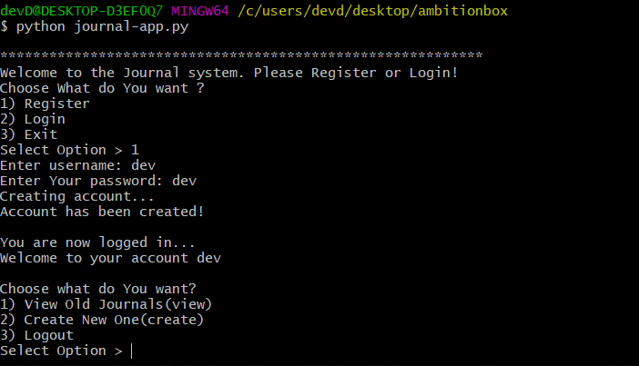

Case -2: Then choose option 2 or if we write create either in uppercase or in lowercase, then we will b asked to write journal as below.

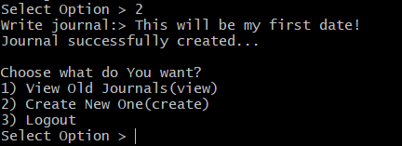

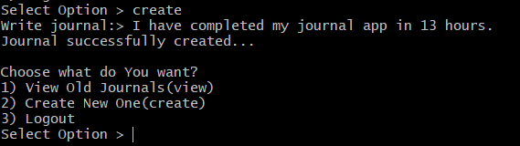

Case-3: IF we choose option 1 or if we write view either in uppercase or in lowercase, then we can see journals as below.

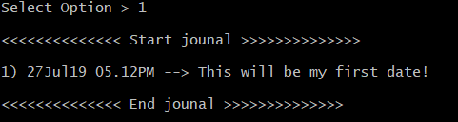

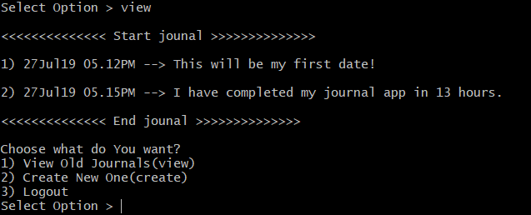

Case-4: If we choose option 3 or if we write logout in either uppercase or lowercase, then we will b logged out from the application.

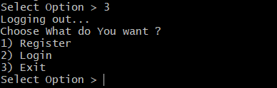

Case-5: IF on the front page if we choose login (for existing user) then we will be prompted as below.

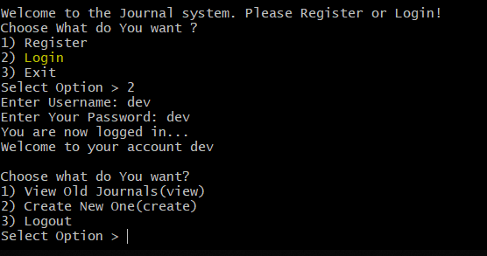

Case-6: If we choose to exit from the application then when we select 3 or if we write exit either in uppercase or in lowercase then the app will be closed.

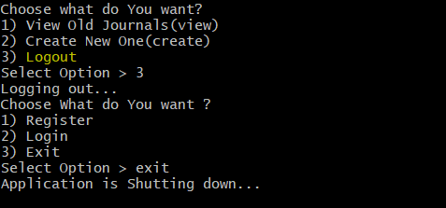

I have created one user named- dev with password – dev.

You can test with this user else can create new one also.